Jack McArthur

Prof. Kirsten Giesbrecht

MATH 528L

6/17/20

Relativistic and Nonrelativistic Dynamics of a Charged Particle in Electromagnetic Waves

The electromagnetic force on a particle of mass m and charge q in an arbitrary electromagnetic field is given by , in which E(**r**, t) represents the electric field at point **r** at time t, B(**r**, t) the magnetic field at point **r** at time t, **v** the particle's velocity d**r**/dt, and **p**, the particle's momentum, which is proportional to its velocity **v**.­1 In three dimensional space, the electromagnetic force equation represents a system of three second-order ordinary differential equations in *t*, the simultaneous solution to which gives the particle’s trajectory as . Models of particle motion in electromagnetic fields are commonly used in particle physics and plasma physics, as electromagnetic fields are the most useful tool for trapping or otherwise manipulating particles.2

One complication to modeling with the electromagnetic force law is that of relativity, which is introduced by the following thought experiment: As the derivative of momentum is equal to the electromagnetic force , we can consider the simple case of an infinite homogeneous electric field with zero magnetic field (, ) to show that the momentum of particle has an unbounded domain,

. The most familiar definition for **p** is m**v**, the product of a particle’s mass and velocity, which implies that the particle’s velocity can also possess any value on . This is not physically possible due to the cosmic speed limit *c*, the speed of light in a vacuum. This presents a contradiction, as |**p**| can be arbitrarily large despite being proportional to **|v|**, which cannot be. As a solution, we redefine **p** to be equal to, where is the Lorenz factor The approximation **p** = m**v** is therefore true at low velocities where γ ≈ 1, but as |**v**| approaches *c* (which is often the case in particle physics), **|p**| goes to ∞, solving our earlier contradiction. Models using the approximation **p** = m**v**, or nonrelativistic models, are still used in physics, as they greatly simplify calculations, but at higher velocities, the more complex relativistic models are necessary for accurate calculations. In this project, numerical solvers in Mathematica were used to study the trajectories of particles in electromagnetic wave systems, and comparisons between nonrelativistic and relativistic predictions were made.

The first EM wave to be considered was the transverse wave, which consists of oscillating E and B fields that oscillate perpendicularly to each other while propagating at the speed of light. It was observed that the particle motion is the sum of a drift component and a periodic component, and the relativistic model diverges from the nonrelativistic model (qualitatively) at around v = 0.25*c*.

A.  B. 

Figure 1: Nonrelativistic (left) vs. relativistic (right) trajectories in a transverse EM wave for the same initial conditions and v=0.23c (A) and v=0.85c (B)

An algorithm was also written that could remove the drifting motion from the solution, allowing the periodic motion to be analyzed separately. From this, the difference between relativistic and nonrelativistic treatments, as well as the velocity of the drift, can be better seen; only at very low velocities (v < 0.23*c*) do the two periodic trajectories and drift velocities align.

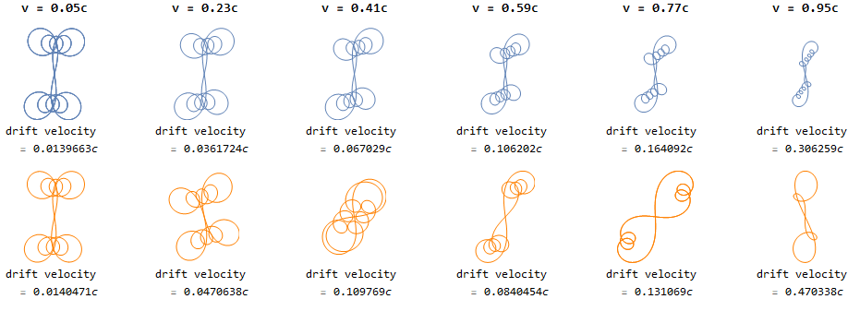

Figure 2: Nonrelativistic (top) vs. relativistic (bottom) periodic trajectory comparisons in a transverse EM wave for the same initial conditions at a variety of initial velocities.

The motion in a circularly polarized wave was also considered. The particle moved in a helical path in the direction of the wave’s propagation. The helical path was actually the sum of two helical paths, one caused by the magnetic field in isolation (which dominated at high velocities due to the term of the force law), and one caused by the electric field in isolation (which dominated at low velocities).

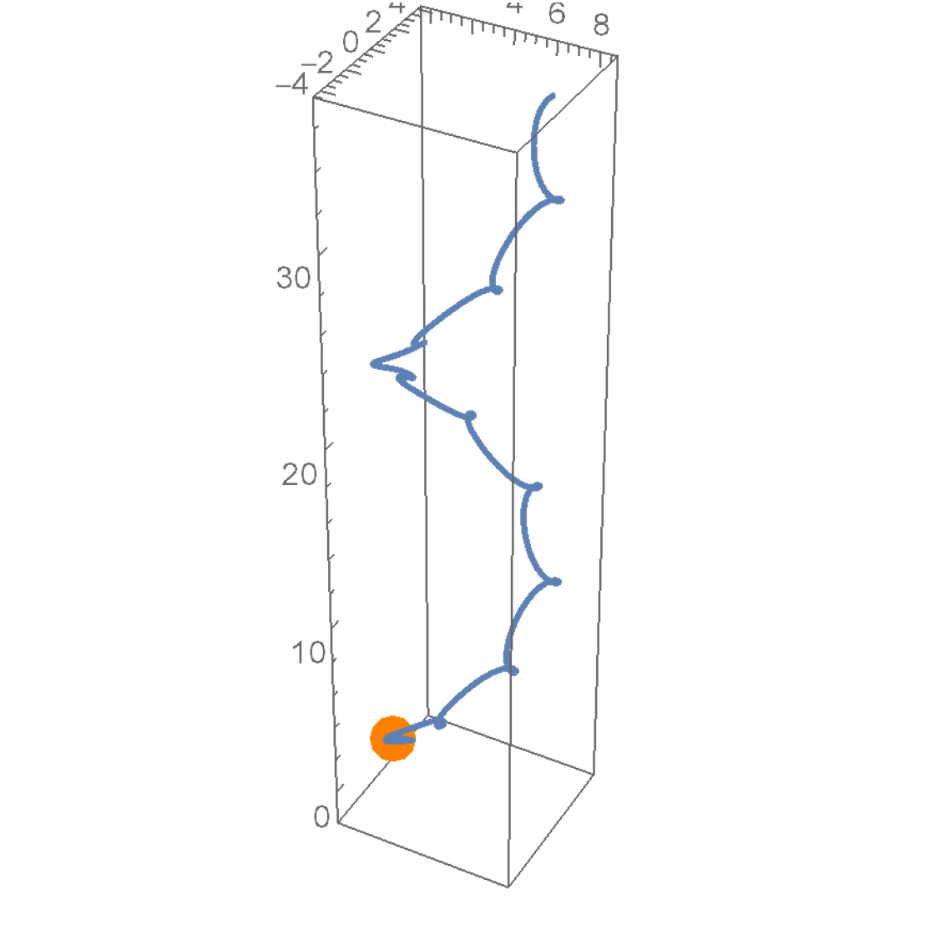 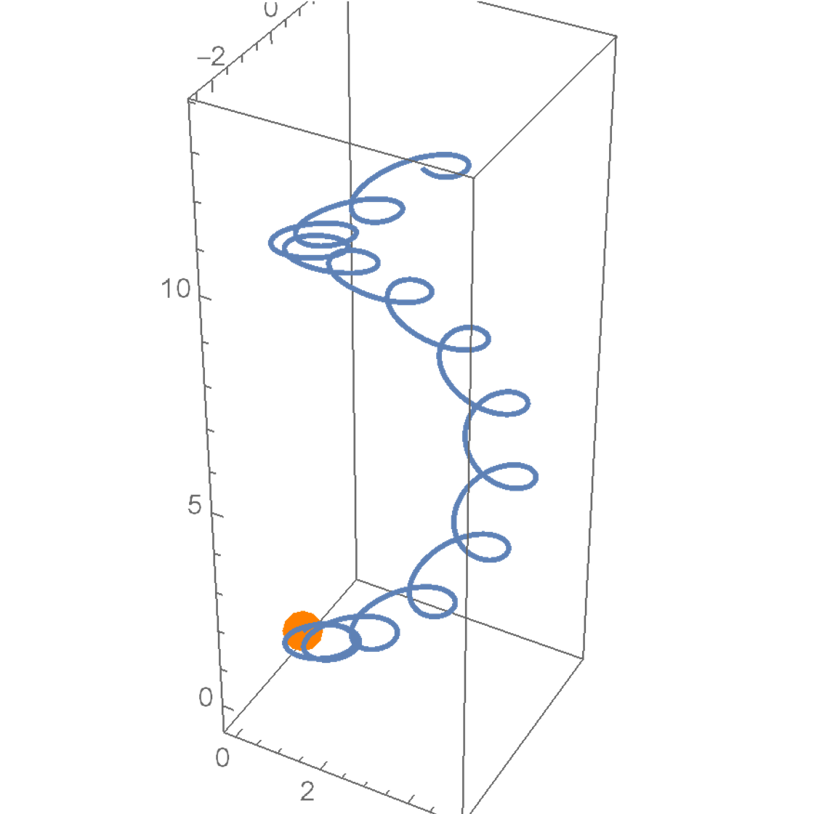 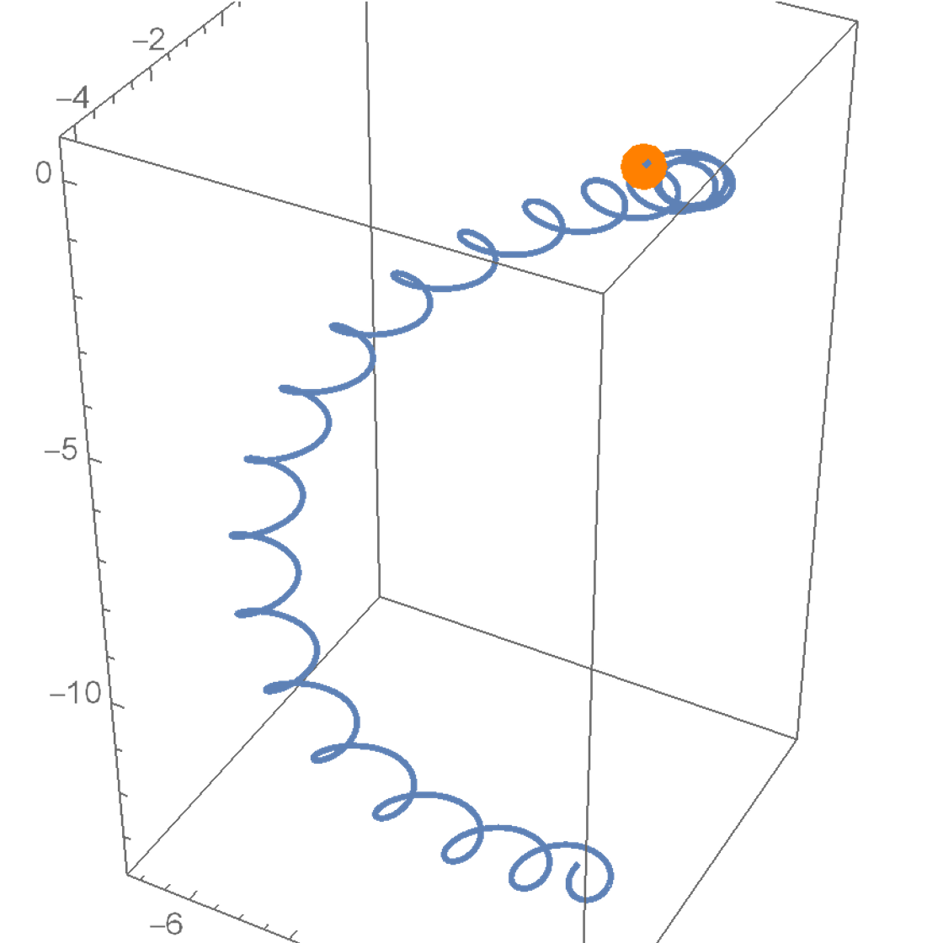

Figure 3: Relativistic trajectories in a circularly polarized wave of a particle starting at the orange dot with initial velocities of v = 0.25*c,* v = 0.5*c*, and v = 0.75*c*, respectively. For v = 0.75c, the particle moves in the negative z direction because the magnetic term of the force law dominates.

The relativistic vs. nonrelativistic comparisons in a circularly polarized wave were also made, and they showed significant differences above v = 0.01*c*, a much lower threshold than the transverse wave case.

Finally, the cases of two superimposed plane waves and two superimposed polarized waves were considered. L. Krlín, M. Zápotocký, and V. Svoboda (2004) report that a relativistic Hamiltonian treatment of a particle in two perpendicular transverse waves leads to chaotic behavior3, as shown by the bold line in Figure 4a. This result was replicated; in both nonrelativistic and relativistic treatments, the two-transverse-wave system oscillates erratically, and the two treatments diverge at very low velocities due to the complicated nature of the model.

A.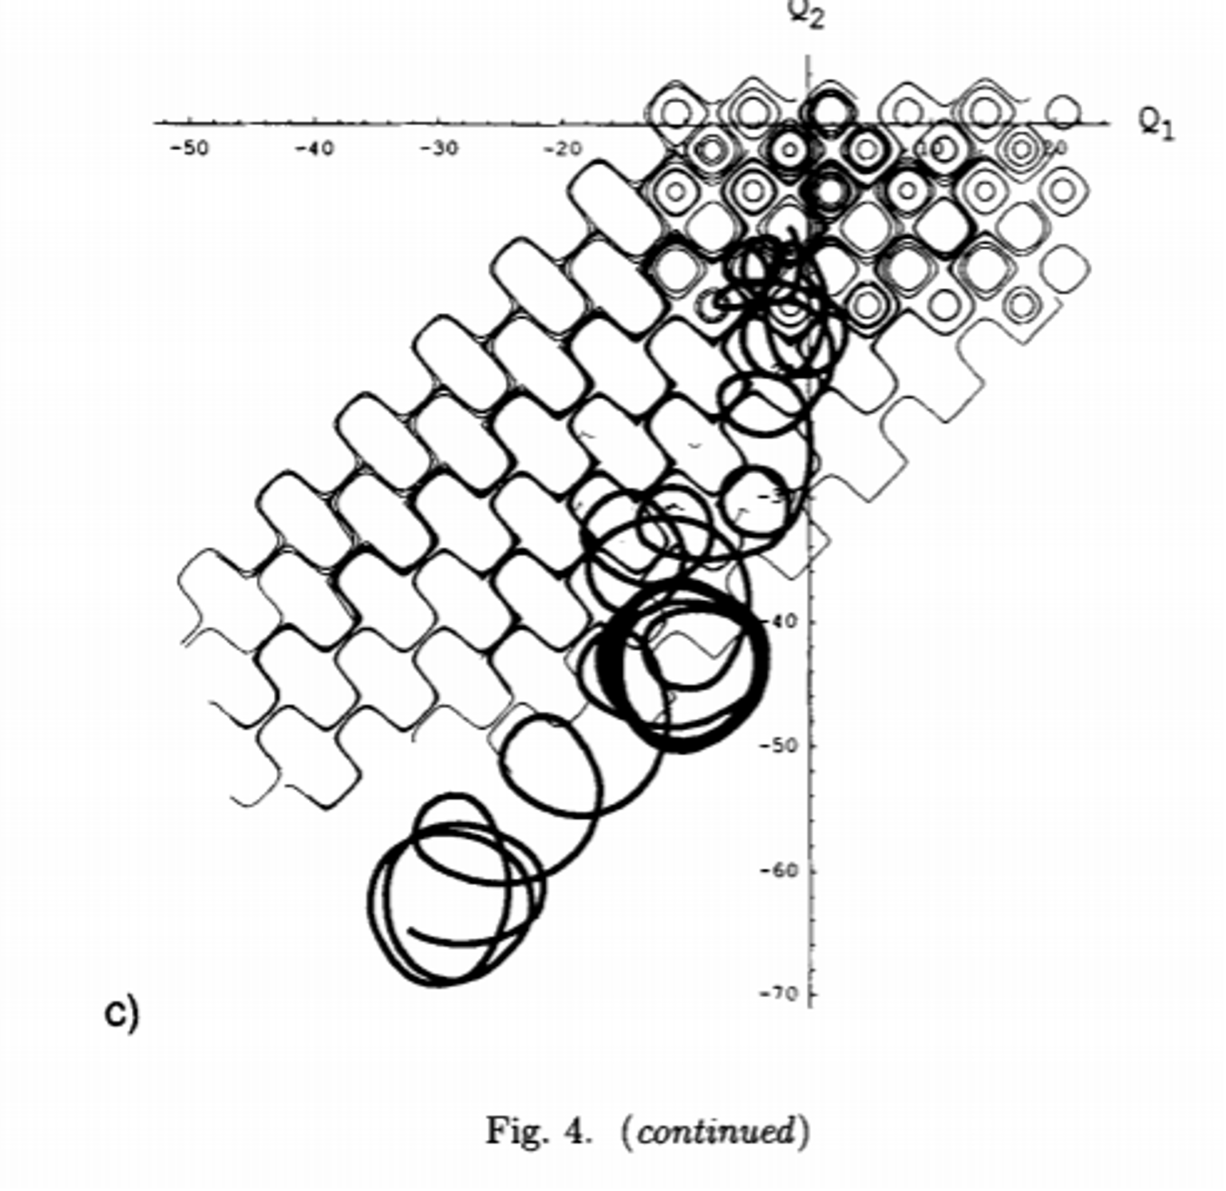 B. 

Figure 4: (A) chaotic motion of a particle in two plane waves (bold line), reproduced from L. Krlín, M. Zápotocký, and V. Svoboda (2004), (B), the nonrelativistic and relativistic trajectories in a similar system with different initial conditions for v = 0.07*c*.

Finally, the chaotic behavior of the two transverse wave and two-circularly polarized-wave systems were analyzed by showing their sensitivity to initial conditions. This analysis was done in the relativistic scenario for both, using all of the same parameters. The transverse waves case showed chaotic behavior on a shorter timescale (18 time units) than the circularly polarized waves case (60 time units), allowing for a qualitative conclusion that the transverse wave case behaves more periodically.

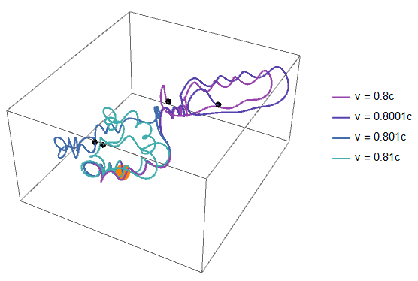 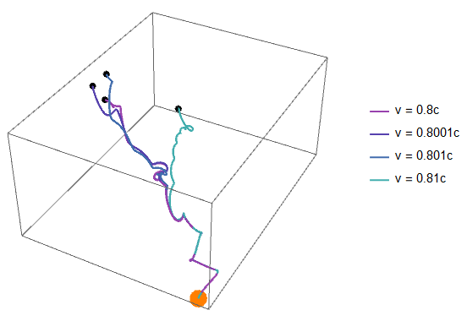

Figure 5: Sensitivity to initial conditions for a particle starting at the orange dot in the two-transverse-wave case in 18 time units (left) and the two-circularly-polarized-wave case in 60 time units (right).

In conclusion, it has been shown that the dynamics of charged particles in electromagnetic waves can be modeled by relativistic and nonrelativistic methods. Some notes on the behaviors of transverse and circularly polarized wave systems were given. Finally, it was determined that nonrelativistic methods are accurate only for velocities that are very small when compared to the speed of light, *c*.

Works Cited

1. “Chapter 1.” *Introduction to Plasma Dynamics*, by A. I. Morozov, Taylor & Francis, 2013, pp. 1–20.
2. Griffiths, David J. *Introduction to Electrodynamics*. Cambridge University Press, 2017.
3. Krlín, L., et al. “Role of Finite Larmor Radius in Chaotic Regime of Waves-Particle Interaction.” *Czechoslovak Journal of Physics*, vol. 54, no. 7, 2004, pp. 759–774., doi:10.1023/b:cjop.0000038529.45640.10.